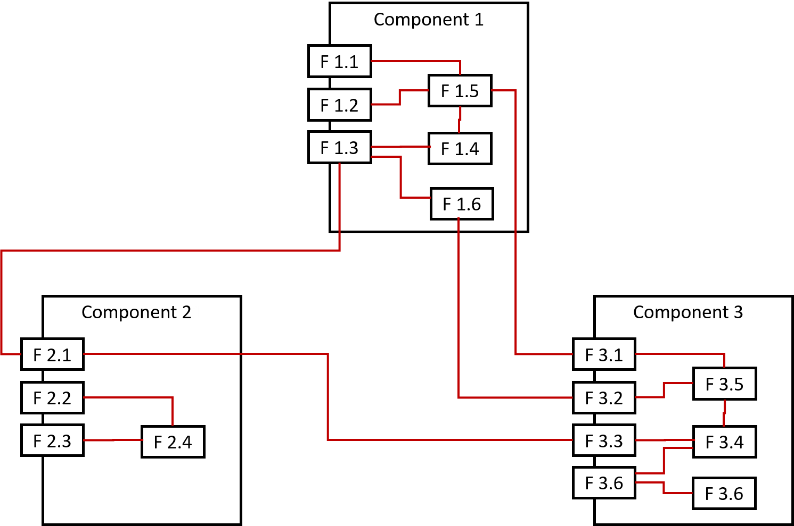

- Question- For the figure above, calculate the cohesion of each component and the average cohesion of the system. Also, calculate the coupling of each component and the average coupling of the system.

